Architecture Pattern:
Have tried best to implement Clean Architecture Principle for coding.
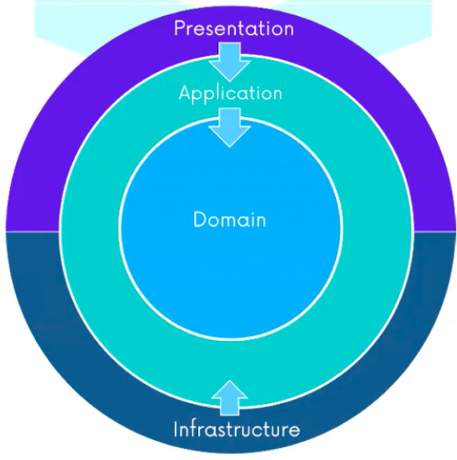

Not Implemented :
- Storing Member Information in Database
- Authentication method for API and UI
- Complete working and clean UI

Areas for improvements:
- Occupation Id, should not come as Input for calculatePremium. Only Occupation should be in the payload.
- AppGateway though implemented but not working as expected.
- JWT Authentication for end points.
- Authetication module for the whole application.

